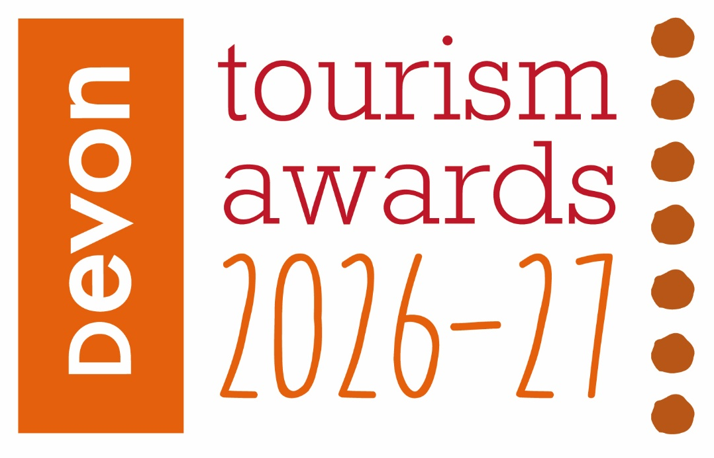

Tourism Event / Festival of the Year

Recognises providers of truly memorable and immersive tourism events and festivals

This sample application form is for information only and all applications must be made via the online application system.

Useful information before you start your application

Before you start your application:
- Read and accept the Applicant Terms and Conditions when prompted.
- Make sure that you are eligible for the category you are considering applying for.
Read the eligibility criteria carefully, if you are deemed ineligible you may be moved to another category where you would be eligible, or your application may be discounted altogether. If you are not sure whether you are eligible, check with the competition organiser before completing your application.
- To avoid duplication in your responses, read all the questions before you start. For most categories each question covers a different aspect of your business.
- Read the guidance information starting ‘judges will be looking for . . .’ for suggestions on what to include in your answers.
- By setting up an account you can save your work and come back to it later – you don’t have to start and submit your application in one sitting.
- Take your time but be mindful of the closing date for applications.
- Be aware of the word limits, they are exact.
- Proof your entry before submitting.

Good luck!

Eligibility criteria

- Events and Festivals making a contribution to the visitor economy with a significant proportion of business generated by people visiting from outside the local area.
- Events could include festivals, fairs, carnivals, shows or celebrations. They can be paid entry or free but should demonstrate innovation and distinctiveness
- The event can be a one off or a rolling series of events.
- Events of all sizes can apply as this category is judged within the context and style of the business.
- Only tourism events who directly serve the end-users are eligible (ie the tourist/ visitor/ guest). Business to business agencies or intermediaries eg that manage business to consumer (B2C) presence for tourism events would not be eligible.
- Events that serve food must now have a minimum food hygiene rating of four out of five. The competition organisers reserve the right to refuse an application if this minimum requirement is not met at any point prior to the awards ceremony. An exception is made for new businesses who have not yet been graded
- The event / festival must take place between 1st September 2025 and 31st August 2026.
- Applications from a chain or group operator must relate to a single event

Applicant & business details
(not scored)

Applicant’s name:

Enter the applicant’s name here.

Applicant’s job title:

Enter the applicant’s job title here.

Applicant’s phone number:

Enter the applicant’s phone number here.

Applicant’s email:

Enter applicant’s email here.

Event name:
Name used to promote the event as you wish it to appear in all publicity materials, on certificates, in presentations etc.:
Enter name here.

Event address:
Enter address here.

Event Date:
Enter the date including year of your event here (note eligibility criteria)

Promotional Description
Provide a promotional description of your event.
- Focus on its strengths and stand out features
- This wording will be used in PR and awards literature
- Wording provided is subject to edit
- 120 words maximum

Enter the promotional description here.

Promotional Images
Provide up to three landscape high resolution photos.
- Photos should be high quality and truly showcase your event
- Photos should not be edited in any way eg embedded text or logos, a collage
- Only include photos that you own the copyright for
- If the photo requires a credit eg photographer, please provide details
- These photos will be used in PR and awards literature

Background
(Not scored)

Briefly outline the story of your event (250 words maximum).
For example:
- Length of time event has been running
- Target market(s) and typical customer profile
- Key milestones in developing the event
- Indication of size of event
- Number of staff employed, if any

Enter information on the background of your event here.

List any awards, ratings and accolades received in the last two years. Include the title, awarding body, level and date (including year) achieved.
For example:
- Successes in this competition and the VisitEngland Awards for Excellence
- TripAdvisor Accolades
- Green Tourism award
- VisitEngland quality assessment, local quality accreditation
- Specific event / festival accolades
- Local business award eg FSB, Chamber of Commerce

Enter information on any awards, ratings or accolades here.

There is no requirement for your business to be quality assessed. However, if you have an independent quality assessment/mystery shopping report from the last two years, you might wish to upload it here (optional).

Enter information on any quality assessments here.

Online presence & reviews
(This section is 30% of the final score)
- Social Media & Website = 20%
- Online Reviews / Visitor Feedback = 10%

Provide links to your online presence relating to this category, which will be reviewed and scored by judges in addition to your answers to the four questions. Other sites may also be checked.
As part of this review, judges will be looking for evidence of your commitment to Accessible and Inclusive Tourism and Regenerative Tourism in addition to your event.

Enter the website URL here.

Accessibility & inclusivity information
Provide links to your accessibility and inclusivity information.

Enter the accessibility & inclusivity information URL here.

If information on your approach to accessibility and inclusivity is not available online, outline the details here (max. 300 words)

Enter the accessibility & inclusivity information here.

Regenerative Tourism information
Regenerative Tourism champions that tourism should leave a place better than it was before. The main goal is for visitors to have a positive impact in the destination or place they visit. Through this we wish to champion actions of suppliers, staff and local stakeholders in supporting the entrant on their delivery to the visitor.
We are looking for actions that support some or all of the below to a standard that could inspire visitors, suppliers and staff in positive actions:
- Climate – actions to decarbonise energy/mobility towards Net Zero
- Circular Economy – clear examples of management of suppliers, waste, recycling, sustainable products and efficient use of resources
- Biodiversity – actions to protect and restore nature
- Place based – respect for local area/communities, tourism that does no harm
Provide links to your regenerative tourism information.

Enter the regenerative tourism information URL here.

If information on your approach to regenerative tourism is not available online, outline the details here (max. 300 words)

Enter the regenerative tourism information here.

Provide links to all business pages/profiles on Facebook, Instagram and X, LinkedIn and TikTok etc.

Enter the social media URL here.

Online review sites / Visitor Feedback
Provide specific links to customer review listings for your business eg TripAdvisor, Facebook, Google etc. Alternatively, if this is no longer available for your Event, please provide a link to visitor testimonials, survey feedback etc.

Enter the URLs here.

Question 1 - Your Top Qualities
(This question is 25% of the final score)

Tell us about up to five ways in which your event is impressive compared to other events (500 words maximum).

Describe the unique selling points, strengths and essence of your event. Judges will be looking for detailed examples of quality from across the event. One or more of the following example areas may be relevant to address in your answer (it is not mandatory to cover every area) and you may have others:
- Quality of your core product and customer experience
- Added extras that delight your visitors, how you exceed expectations before, during and after your event
- How you care for your team and training with specialist skills specific to the changing needs of visitors
- Use and promotion of local services and suppliers, including food & drink offer centred on locally sourced produce
- Innovative marketing and PR, including partnerships with other businesses
- Innovative adaption, diversification and/ or resilience building
- Sustainable practices that align to regenerative tourism, this may include:
- Climate – actions to decarbonise energy/mobility towards Net Zero
- Circular Economy – clear examples of management of suppliers, waste, recycling, sustainable products and efficient use of resources
- Biodiversity – actions to protect and restore nature
- Place based – respect for local area/communities, use of local suppliers, tourism that does no harm
- Inclusive facilities, experience and welcome, this may include:
- how you attract a diverse audience
- how you provide for visitors with access needs and
- what you have in place to ensure all visitors are welcomed, supported and encouraged to take part or enjoy their stay with you

Enter answer to question 1 here.

Links to relevant supporting evidence online (optional):
It is not a requirement to submit supporting evidence; however, if you do, ensure that the focus is on the quality and relevancy of the evidence submitted to this question rather than quantity.
Any written answers that are included within the supplementary evidence, attempting to circumvent the question word counts, will be disregarded.

Enter links to supplementary evidence here.

Question 2 - Your Recent Improvements
(This question is 20% of the final score)

Tell us about up to five ways in which you have developed your event and/or improved the visitor experience over the last two years (500 words maximum).

Explain your reasons for making the improvements and indicate which parts of the event are impacted. Judges will be looking for examples of improvements from across the event. One or more of the following example areas may be relevant to address in your answer (it is not mandatory to cover every area) and you may have others too:
(Only include examples of improvements undertaken in the last two years.)
- Have your improvements been based on customer feedback or staff suggestions
- Promotional initiatives eg new website
- Improving the skills of you and your team
- Development and changes made to your event eg upgrade of facilities, enhancements to your services, innovation etc
- Sustainable practices that align to regenerative tourism, this may include:
- Climate – actions to decarbonise energy/mobility towards Net Zero
- Circular Economy – clear examples of management of suppliers, waste, recycling, sustainable products and efficient use of resources
- Biodiversity – actions to protect and restore nature
- Place based – respect for local area/communities, use of local suppliers, tourism that does no harm
- Inclusive facilities, experience and welcome, this may include:
- how you attract a diverse audience
- how you provide for visitors with access needs and
- what you have in place to ensure all visitors are welcomed, supported and encouraged to take part or enjoy their stay with you
- Innovative adaption, diversification and/ or resilience building
- Use of digital technologies such as automated services, robotics and artificial intelligence (AI)
- If your entry relates to a one off event, please focus on the development element of your event, eg areas you have taken into consideration when planning
- Approximate date of improvement

Enter answer to question 2 here.

Links to relevant supporting evidence online (optional):
It is not a requirement to submit supporting evidence; however, if you do, ensure that the focus is on the quality and relevancy of the evidence submitted to this question rather than quantity.
Any written answers that are included within the supplementary evidence, attempting to circumvent the question word counts, will be disregarded.

Enter links to supplementary evidence here.

Question 3 - Your Results
(This question is 15% of the final score)

Tell us about three evidenced or anticipated successes from your event providing figures where relevant (these may relate to online activities) (300 words maximum).

Judges will be looking for detailed examples of successes from across the event. One or more of the following example areas may be relevant to address in your answer (it is not mandatory to cover every area) and you may have others too:
- Whether you are able to attribute success directly to any of the improvements that you’ve made (mentioned in Question 2)
- Overall growth of event
- Percentage increase in visitor numbers, sales, customer satisfaction, online booking
- Wastage reduction and improvement in environmental impact, savings made
- Increase in repeat business (unless a one off event)
- Business generated from marketing activity
- Growth of social media following and engagement
- The significance of the level of impact on your event

Enter answer to question 3 here.

Links to relevant supporting evidence online (optional):
It is not a requirement to submit supporting evidence; however, if you do, ensure that the focus is on the quality and relevancy of the evidence submitted to this question rather than quantity.
Any written answers that are included within the supplementary evidence, attempting to circumvent the question word counts, will be disregarded.

Enter links to supplementary evidence here.

Question 4 – Your Future Plans
(This question is 10% of the final score)

- Tell us about three ways you will develop and promote your event over the next year and the reasons why (300 words maximum).

If your entry relates to a one off event that won’t run again, please include details of next steps, eg actions with feedback, PR etc.

Judges will be looking for detailed examples of future plans from across the event with a clear rationale. One or more of the following example areas may be relevant to address in your answer (it is not mandatory to cover every area) and you may have others too:
- Continued adaptation, diversification and resilience building
- Sustainable practices that align to regenerative tourism, this may include:
- Climate – actions to decarbonise energy/mobility towards Net Zero
- Circular Economy – clear examples of management of suppliers, waste, recycling, sustainable products and efficient use of resources
- Biodiversity – actions to protect and restore nature
- Place based – respect for local area/communities, use of local suppliers, tourism that does no harm
- Inclusive facilities, experience and welcome, this may include:
- how you attract a diverse audience
- how you provide for visitors with access needs and
- what you have in place to ensure all visitors are welcomed, supported and encouraged to take part or enjoy their stay with you
- Development, innovation, information provision, upgrade of facilities, enhancements to your event
- Improving the skills of you and your team
- Marketing and PR, including partnerships with other businesses
- Operational efficiency
- Use of digital technologies such as automated services, robotics and artificial intelligence (AI)

Enter answer to question 4 here.

Links to relevant supporting evidence online (optional):
It is not a requirement to submit supporting evidence; however, if you do, ensure that the focus is on the quality and relevancy of the evidence submitted to this question rather than quantity.
Any written answers that are included within the supplementary evidence, attempting to circumvent the question word counts, will be disregarded.

Enter links to supplementary evidence here.

