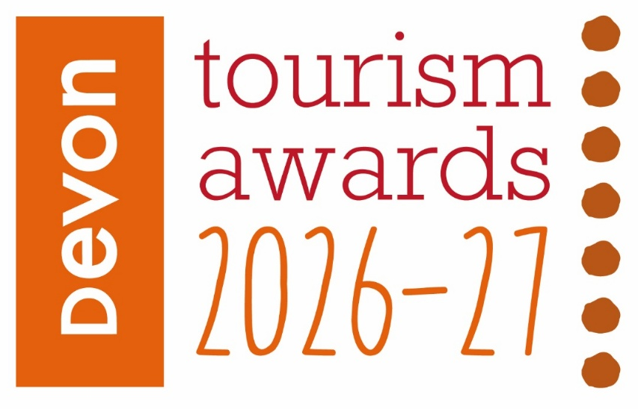

Visitor Information Superstars Award

Recognises teams, businesses and community initiatives that excel in welcoming visitors to the area, including the provision of wide ranging information and encouragement to make the most of their time in the destination area.

This sample application form is for information only and all applications must be made via the online application system.

Useful information before you start your application

Before you start your application:
- Read and accept the Applicant Terms and Conditions when prompted.
- Make sure that you are eligible for the category you are considering applying for.
Read the eligibility criteria carefully, if you are deemed ineligible you may be moved to another category where you would be eligible, or your application may be discounted altogether. If you are not sure whether you are eligible, check with the competition organiser before completing your application.
- To avoid duplication in your responses, read all the questions before you start. For most categories each question covers a different aspect of your business.
- Read the guidance information starting ‘judges will be looking for . . .’ for suggestions on what to include in your answers.
- By setting up an account you can save your work and come back to it later – you don’t have to start and submit your application in one sitting.
- Take your time but be mindful of the closing date for applications.
- Be aware of the word limits, they are exact.
- Proof your entry before submitting.

Good luck!

Eligibility criteria

- Directly involved in tourism, making a contribution to the visitor economy with a significant proportion of business generated by people visiting from outside the local area
- Entrants can be teams or organisations and must be involved in face-to-face liaison with individual enquiries as well as on the phone or online.
- Visitors must be able to make general enquiries regarding the visitor provision in the local area.
- Information provided must be independent of commercial bias
- Information provided must cover a variety of likely visitor interests in the overall geographic area, not just a single business (e.g. an attraction reception may be eligible if it offers information about the wider area and not just that relating to their attraction)
- Automated ‘chat room’ communications are not eligible
- The service must be operational during the judging period
- Teams and operations of all sizes can apply if they are engaged in providing a wide range of information to encourage visitors to maximise their stay in the area. This would include recommendations for accommodation, eateries, attractions to visit etc.
- Only tourism businesses who directly serve the end-users are eligible (i.e. the tourist/ visitor/ guest). Business to business agencies or intermediaries e.g. that manage business to consumer (B2C) presence for tourism businesses would not be eligible.
- Businesses that serve food must have a minimum food hygiene rating of four out of five. The competition organisers reserve the right to refuse an application if this minimum requirement is not met at any point prior to the awards ceremony. An exception is made for new businesses who have not yet been graded
- Operations that have been operating for at least three months and up to two years when applications open are strongly recommended to apply to the New Tourism Business of the Year category before considering applying to any other categories
  - For the purpose of eligibility for this competition, ‘trading’ means serving customers. If the business has not been trading this long, then they will need to wait to apply to the competition in 2027/28
- Applications from a chain or group operator must relate to a single site and not multiple sites

Applicant & business details
(not scored)

Applicant’s name:

Enter the applicant’s name here.

Applicant’s job title:

Enter the applicant’s job title here.

Applicant’s phone number:

Enter the applicant’s phone number here.

Applicant’s email:

Enter applicant’s email here.

Service name:
Name of service application relates to. Give the name used to promote the service as you wish it to appear in all publicity materials, on certificates, in presentations etc.:
Enter your business name here.

Service address:
Enter your business address here.

Phone number for visitor enquiries:
Enter your business number here.

Email for visitor enquiries:

Enter your email address here.

Closures during judging period (the judging period runs from 31st May – 30th September 2026):

Enter closures during the judging period here.

When did your service start operating?

For businesses trading for less than two years, what exact date did the business relating to this application start trading? For businesses trading for more than two years, what year did the business relating to this application start trading?

No of staff
Enter the number of staff employed (full time equivalent) here, including volunteers.

Enter the number of staff here.

Promotional Description
Provide a promotional description of your service.
- Focus on its strengths and stand out features
- Write your description with regard to this category
- This wording will be used in PR and awards literature
- Wording provided is subject to edit
- 120 words maximum

Enter the promotional description here.

Promotional Images
Provide up to three landscape high resolution photos.
- Photos should be of a high quality that showcase your service
- Photos should not be edited in any way eg embedded text or logos, a collage
- Only include photos that you own the copyright for
- If the photo requires a credit eg photographer, please provide details
- These photos will be used in PR and awards literature

Background
(Not scored)

Briefly outline the story of your operation (250 words maximum).
For example:
- Length of time service has been trading and time under current ownership
- Key milestones in developing the business
- Indication of size of business
- Number of staff employed, if any

Enter information on the background of your business here.

List any awards, ratings and accolades received in the last two years. Include the title, awarding body, level and date achieved.
For example:
- Successes in this competition and the VisitEngland Awards for Excellence
- TripAdvisor Accolades
- Green Tourism award
- VisitEngland quality assessment, local quality accreditation
- Business, quality or service awards

Enter information on any awards, ratings or accolades here.

There is no requirement for your business to be quality assessed. However, if you have an independent quality assessment/mystery shopping report from the last two years, you might wish to upload it here (optional).

Enter information on any quality assessments here.

Online presence & reviews
(This section is 30% of the final score)
- Social Media & Website = 20%
- Online Reviews = 10%

Provide links to your online presence relating to this category, which will be reviewed and scored by judges in addition to your answers to the four questions. Other sites may also be checked.
As part of this review, judges will be looking for evidence of your commitment to Accessible and Inclusive Tourism and Regenerative Tourism in addition to your focus on providing visitor information& a great welcome.

Enter the website URL here.

Accessibility & inclusivity information
Provide links to your accessibility and inclusivity information.

Enter the accessibility & inclusivity information URL here.

If information on your approach to accessibility and inclusivity is not available online, outline the details here (max. 300 words)

Enter the accessibility & inclusivity information here.

Regenerative Tourism information
Regenerative Tourism champions that tourism should leave a place better than it was before. The main goal is for visitors to have a positive impact in the destination or place they visit. Through this we wish to champion actions of suppliers, staff and local stakeholders in supporting the entrant on their delivery to the visitor.
We are looking for actions that support some or all of the below to a standard that could inspire visitors, suppliers and staff in positive actions:
- Climate – actions to decarbonise energy/mobility towards Net Zero
- Circular Economy – clear examples of management of suppliers, waste, recycling, sustainable products and efficient use of resources
- Biodiversity – actions to protect and restore nature
- Place based – respect for local area/communities, tourism that does no harm
Provide links to your regenerative tourism information.

Enter the regenerative tourism information URL here

If information on your approach to regenerative tourism is not available online, outline the details here (max. 300 words)

Enter the regenerative tourism information here.

Provide links to all business pages/profiles on Facebook, Instagram and X, LinkedIn and TikTok etc.

Enter the social media URL here.

Online review sites
Provide specific links to your customer review listings e.g. TripAdvisor, Facebook, Google, Euan’s Guide, UpFront Reviews etc

Enter the online review URL here.

Question 1 - Your Top Qualities
(This question is 20% of the final score)

Tell us about up to five ways in which your team/ organisation is impressive compared to others when welcoming visitors and providing information to meet & exceed the needs of visitors to your area (500 words maximum).

Describe the unique selling points, strengths and essence of your team / organisation. Judges will be looking for detailed examples of quality from across the operation. One or more of the following example areas may be relevant to address in your answer (it is not mandatory to cover every area) and you may have more:
- Quality of your core product and customer experience
- Added extras and how you and your team go above and beyond to ensure your visitors have an excellent experience when visiting the area
- How you care for your team and training with specialist skills specific to the changing needs of visitors
- Use and promotion of local businesses, suppliers and produce i.e. retail, displays, artwork, food and drink etc.
- Innovative marketing and PR, including partnerships with other local tourism and hospitality businesses
- Innovative adaption, diversification and/or resilience building
- Sustainable practices that align to regenerative tourism, this may include:
- Climate – actions to decarbonise energy/mobility towards Net Zero
- Circular Economy – clear examples of management of suppliers, waste, recycling, sustainable products and efficient use of resources
- Biodiversity – actions to protect and restore nature
- Place based – respect for local area/communities, use of local suppliers, tourism that does no harm
- Inclusive facilities, experience and welcome, this may include:
- how you attract a diverse audience
- how you provide for visitors with additional needs
- what you have in place to ensure all visitors are welcomed, supported and encouraged to take part or enjoy their stay when visiting the area

Enter answer to question 1 here.

Links to relevant supporting evidence online (optional):
It is not a requirement to submit supporting evidence; however, if you do, ensure that the focus is on the quality and relevancy of the evidence submitted to this question rather than quantity.
Any written answers that are included within the supplementary evidence, attempting to circumvent the question word counts, will be disregarded.
Enter links to supplementary evidence here.

Question 2 - Your Recent Improvements
(This question is 20% of the final score)

Tell us about up to five ways in which you have developed and improved your visitor experience over the last two years (500 words maximum).

Explain your reasons for making the improvements and indicate which parts of the business are impacted. Judges will be looking for examples of improvements from across the business. One or more of the following example areas may be relevant to address in your answer (it is not mandatory to cover every area) and you may have more:
(Only include examples of improvements undertaken in the last two years.)
- Have your improvements been based on customer feedback or staff suggestions
- Promotional initiatives e.g. new website, marketing, partnership working, campaigns etc
- Improving the skills of you and your team
- Expansion, upgrade of facilities, enhancements to the information provision and / or services you offer
- Sustainable practices that align to regenerative tourism, this may include:
- Climate – actions to decarbonise energy/mobility towards Net Zero
- Circular Economy – clear examples of management of suppliers, waste, recycling, sustainable products and efficient use of resources
- Biodiversity – actions to protect and restore nature
- Place based – respect for local area/communities, use of local suppliers, tourism that does no harm
- Inclusive facilities, experience and welcome, this may include:
- how you attract a diverse audience
- how you provide for visitors with additional needs
- what you have in place to ensure all visitors are welcomed, supported and encouraged to take part or enjoy their stay in the area
- Innovative adaption, diversification and/or resilience building
- Use of digital technologies such as automated services, robotics and artificial intelligence (AI)
- Approximate date of improvement

Enter answer to question 2 here.

Links to relevant supporting evidence online (optional):
It is not a requirement to submit supporting evidence; however, if you do, ensure that the focus is on the quality and relevancy of the evidence submitted to this question rather than quantity.
Any written answers that are included within the supplementary evidence, attempting to circumvent the question word counts, will be disregarded.

Enter links to supplementary evidence here.

Question 3 - Your Results
(This question is 15% of the final score)

Tell us about three successes from the last year in meeting & exceeding the needs of your visitors, providing figures where relevant (300 words maximum).

Judges will be looking for detailed examples of successes from across the operation. One or more of the following example areas may be relevant to address in your answer (it is not mandatory to cover every area) and you may have more:
- Whether you are able to attribute success directly to any of the improvements that you’ve made (mentioned in Question 2)
- Increase in customer satisfaction, sales, referrals to local businesses, positive reviews etc
- Wastage reduction and improvement in environmental impact, savings made
- Business generated from marketing activity
- Growth of social media following and engagement
- The significance of the level of impact your team/ organisation has in the local area

Enter answer to question 3 here.

Links to relevant supporting evidence online (optional):
It is not a requirement to submit supporting evidence; however, if you do, ensure that the focus is on the quality and relevancy of the evidence submitted to this question rather than quantity.
Any written answers that are included within the supplementary evidence, attempting to circumvent the question word counts, will be disregarded.

Enter links to supplementary evidence here.

Question 4 – Your Future Plans
(This question is 15% of the final score)

Tell us about three ways you will develop and promote your welcome & service to meet the needs of visitors over the next year and the reasons why (300 words maximum).

Judges will be looking for detailed examples of future plans from across the business with a clear rationale. One or more of the following example areas may be relevant to address in your answer (it is not mandatory to cover every area) and you may have others too:
- Continued adaptation, diversification and resilience building
- Sustainable practices that align to regenerative tourism, this may include:
- Climate – actions to decarbonise energy/mobility towards Net Zero
- Circular Economy – clear examples of management of suppliers, waste, recycling, sustainable products and efficient use of resources
- Biodiversity – actions to protect and restore nature
- Place based – respect for local area/communities, use of local suppliers, tourism that does no harm
- Inclusive facilities, experience and welcome, this may include:
- how you attract a diverse audience
- how you provide for visitors with access needs and
- what you have in place to ensure all visitors are welcomed, supported and encouraged to take part or enjoy their stay with you
- Information provision, upgrade of facilities, enhancements to your services
- Improving the skills of you and your team
- Marketing and PR, including partnerships with other local businesses
- Operational efficiency
- Use of digital technologies such as automated services, robotics and artificial intelligence (AI)

Enter answer to question 4 here.

Links to relevant supporting evidence online (optional):
It is not a requirement to submit supporting evidence; however, if you do, ensure that the focus is on the quality and relevancy of the evidence submitted to this question rather than quantity.
Any written answers that are included within the supplementary evidence, attempting to circumvent the question word counts, will be disregarded.

Enter links to supplementary evidence here.

